Delocalized $π$ Bonds in carbon dioxide
Che Xuanming
In China, when students were in junior high school, we were told that the carbon-oxygen bond in carbon dioxide is a double bond. But in high school, the teacher emphasized that what we learned in middle school was wrong and that carbon dioxide was actually made up of delocalized $π$ bonds.

We have a symbol $Π_{3}^{4}$ for the delocalized bond, where the symbol on the left is capitalized $π$, indicating that the delocalized bond is formed, the lower right half indicates that the delocalized $π bonds$ consists of three atoms, and the upper half indicates that a total of four electrons are involved in forming the delocalized $π$ bonds.

In carbon dioxide, we usually think of it as being made up of two delocalized $π$ bonds，calld $Π_{3}^{4}$. It is also interesting that we think that the oxygen atoms do not participate in hybridization.

Now I'm going to show you what we think the structure of carbon dioxide is.
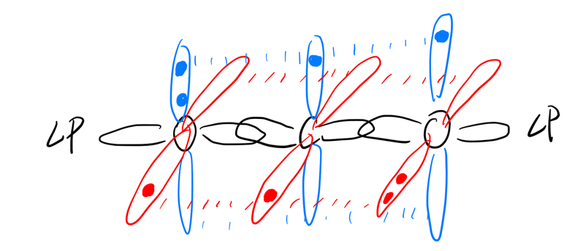
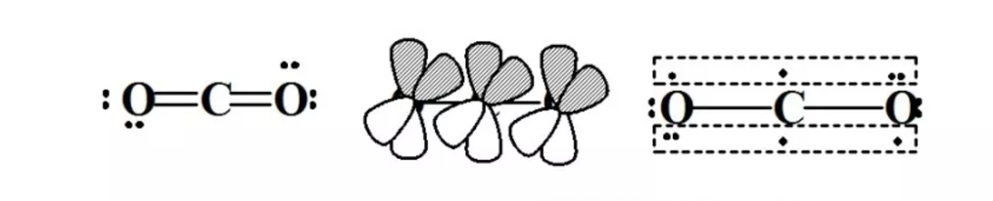
When I look up relevant information on foreign websites, I find it very difficult, most people do not agree with this theory. But I still got some information in Housecroft & Sharpe《Inorganic Chemistry》
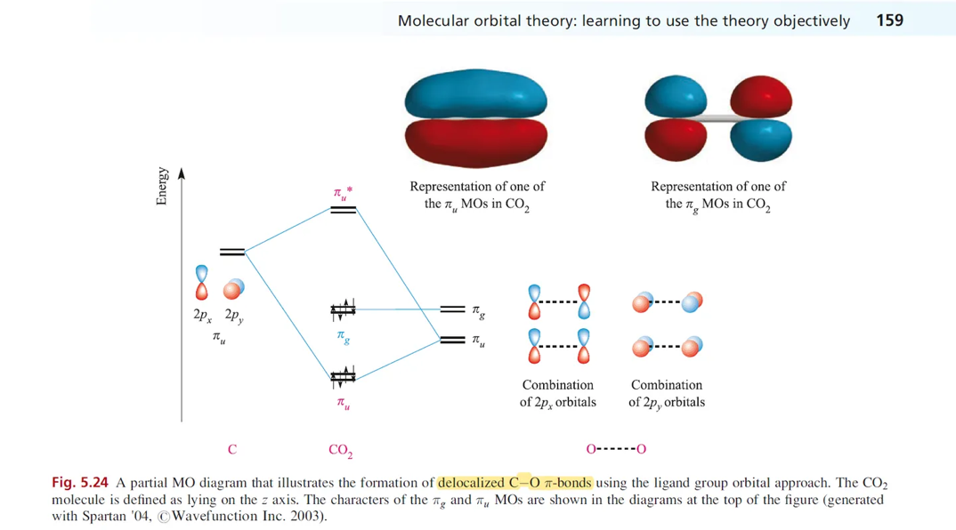
Some historical reasons
From the 1950s to the 1970s, under the influence of various factors, the Chinese academic circle repeatedly criticized the resonance theory proposed by Pauling, an American chemist. The emphasis on the " delocalized $π$ bonds " model, giving this representation of $Π_{3}^{4}$, was put forward by Chinese chemists in the 1950s to 1960s in order to solve the problem of "how to explain the average bond length without resonance in teaching". Foreign textbook editors do not have the historical burden of "criticizing resonance theory" (mainly outside the Soviet Union and China, many textbooks in Eastern Europe retain the resonance structure formula), and naturally can replace the so-called " delocalized $π$ bonds " model with resonance theory.

